Exercise 1 – Spatial Interpolation (Surfer) Surface Modeling

Access the SURFER software system by double-clicking its icon on the desktop or pressing Start→ Programs→ Golden Software Surfer 7→ Surfer 7 Demo

- Create a continuous grid from discrete point data…

- From the main menu click Grid à Data, then select the Demogrid.dat file in the …\Samples subdirectory. The Scattered Data Interpolation box will pop-up.
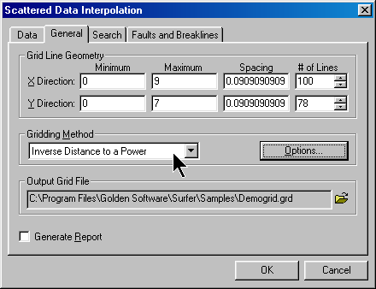
- Grid Line Geometry sets the analysis frame configuration by defining the extent and cell size (use defaults)
- Gridding Method box specifies the interpolation techniques (use Inverse Distance to a Power)
- Click on the Folder icon to pop-up the Save Grid As box.
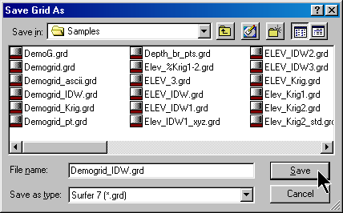
- In the Output Grid box, specify Demogrid_IDW.grd as the output file name.
- Click OK to derive the data defining a continuous IDW surface using the default IDW specifications.

- Create a contour map…
- From the main menu click MAP à Contour à New Contour map → OPEN and specify the Demogrid_IDW.grd data file you just derived. Click OK to bring up the Contour dialog box…

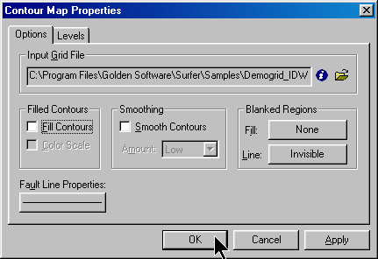 then click OK to generate a default contour map…

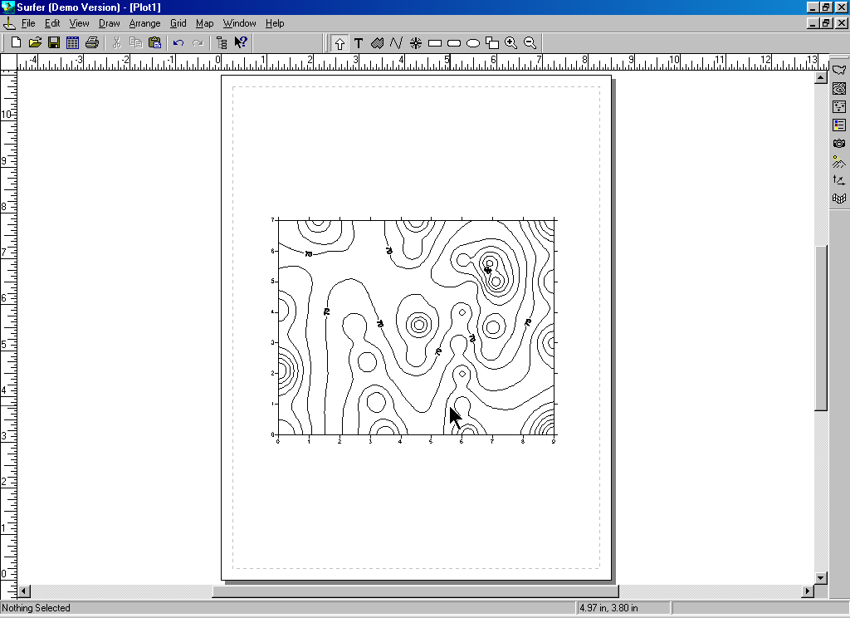 Double-click on the plot to pop-up the Contour map dialog box then check the “Fill Contours” box and press OK…

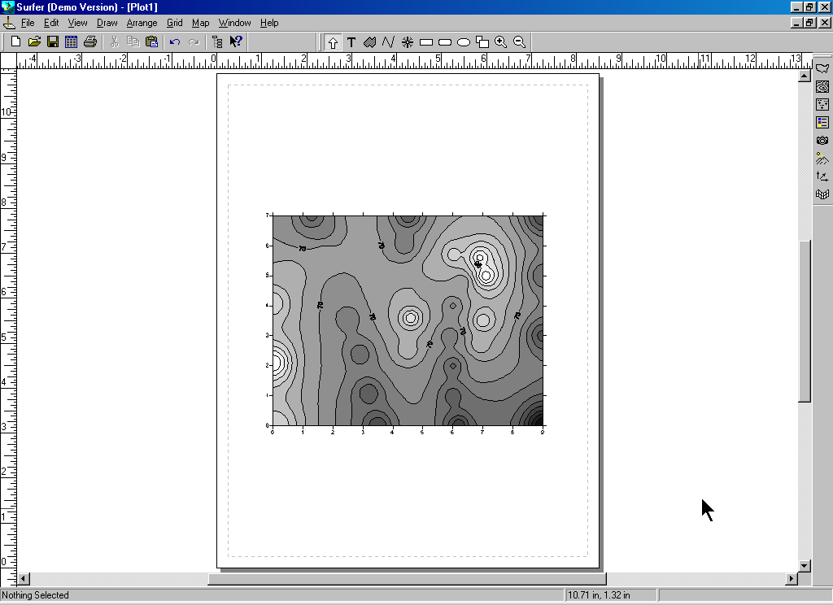 Double-click on the plot to pop-up the Contour map dialog box switch to the Levels tab then double-click on the “Fill” button to pop-up the Fill dialog box. Click on the Foreground Color button to pop-up the Color Spectrum dialog box.

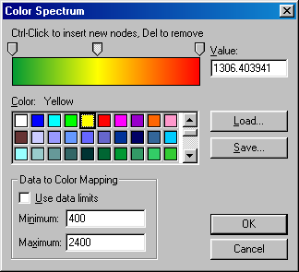 Click on the left arrow just above the color spectrum and assign the color green.
Click on the right arrow and assign red.
Ctrl/click in the middle of the spectrum and assign yellow.
Click OK, OK and OK to generate the color filled contour plot.
Click on the plot then resize and reposition it to the top of the workspace.

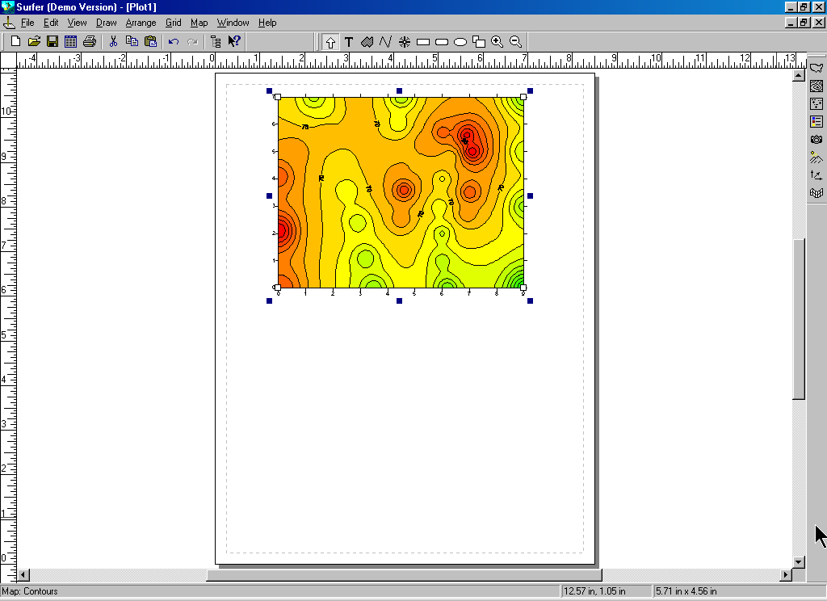

- Create a wireframe plot…
- From the main menu click MAP à Wireframe à OPEN → Demogrid_IDW.grd → OK to pop-up the Wireframe Properties box.
- Click on OK to generate a wireframe plot of the Elev_IDW1 surface using the default parameters.
- Click on the plot then resize and reposition it to the bottom of the workspace.

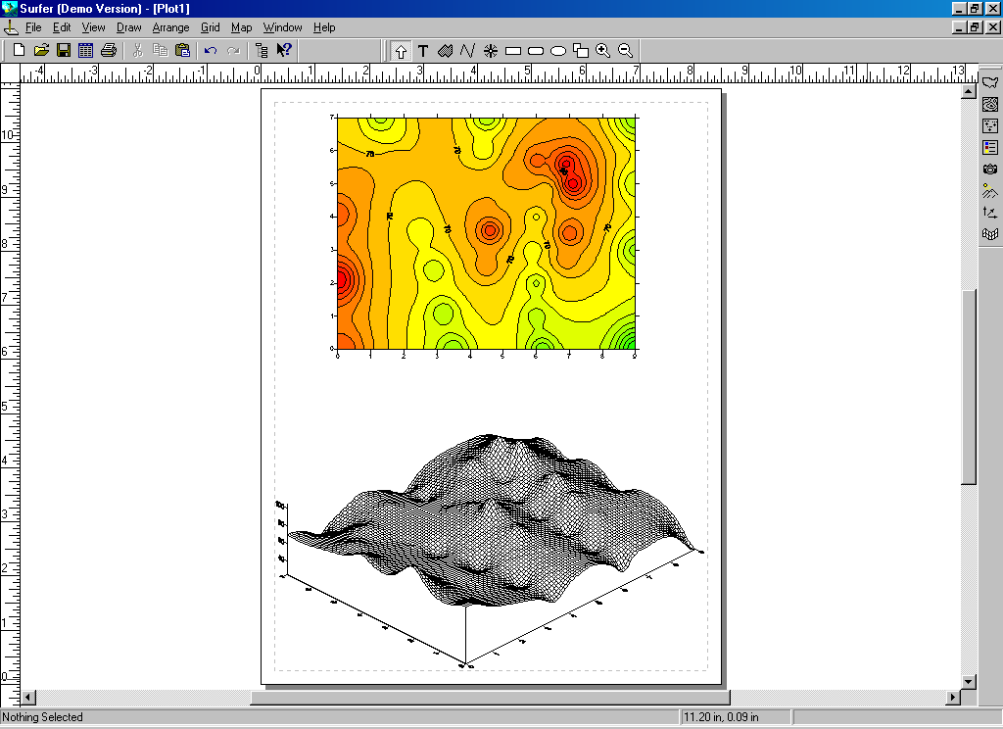

- Graphically overlay the contour and wireframe maps…
- Shift/click to select both the contour and the wireframe plots.
- Then on the main menu, click Map à Overlay Maps.

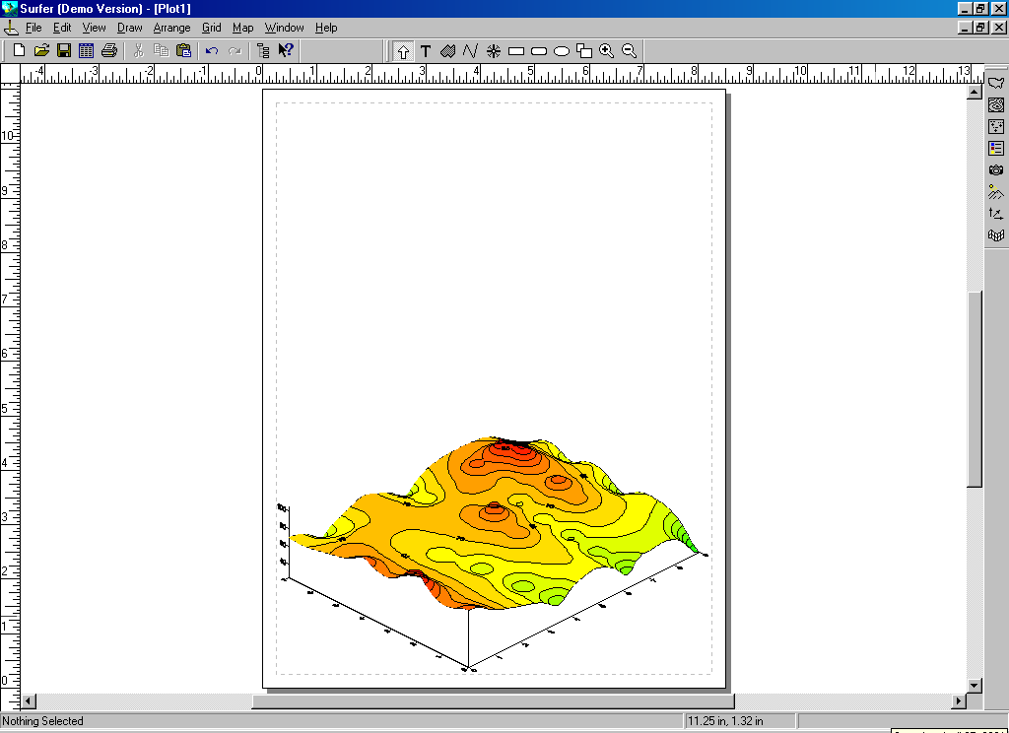
Exercise 2 – Percent Difference Map (Surfer) Surface Modeling

